Instructions to convert an image for GCBasic SSD1289 driver:

1. Open the ImageConverter 565 v2.3 program
2. Open the Image you want to convert

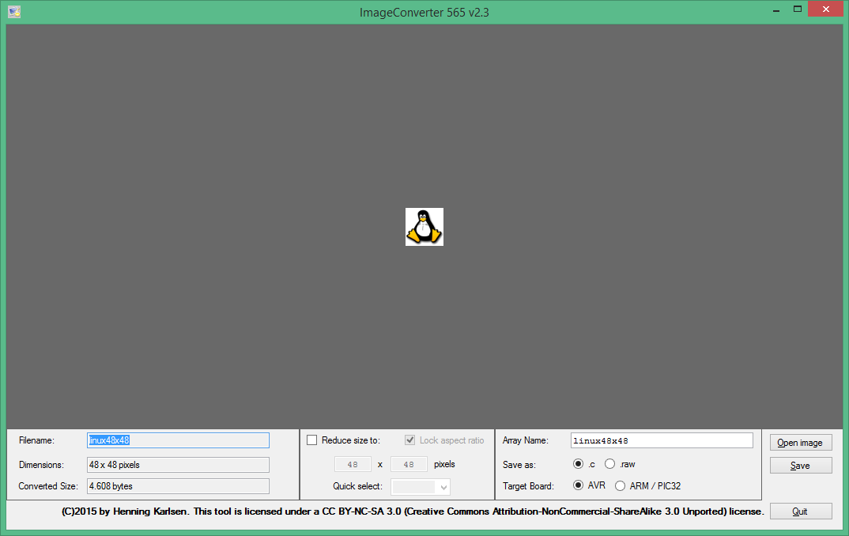

1. Make sure to check out how many pixels your image has. For example in the picture above the image has 48x48 pixels
2. You have to save your image as : .c and Target Board : AVR
3. Press save and name it as Linux.c .
4. From the edit menu use the replace tool and replace the // with ‘ or ;
5. if you followed the instructions correctly you will be able to see the following file

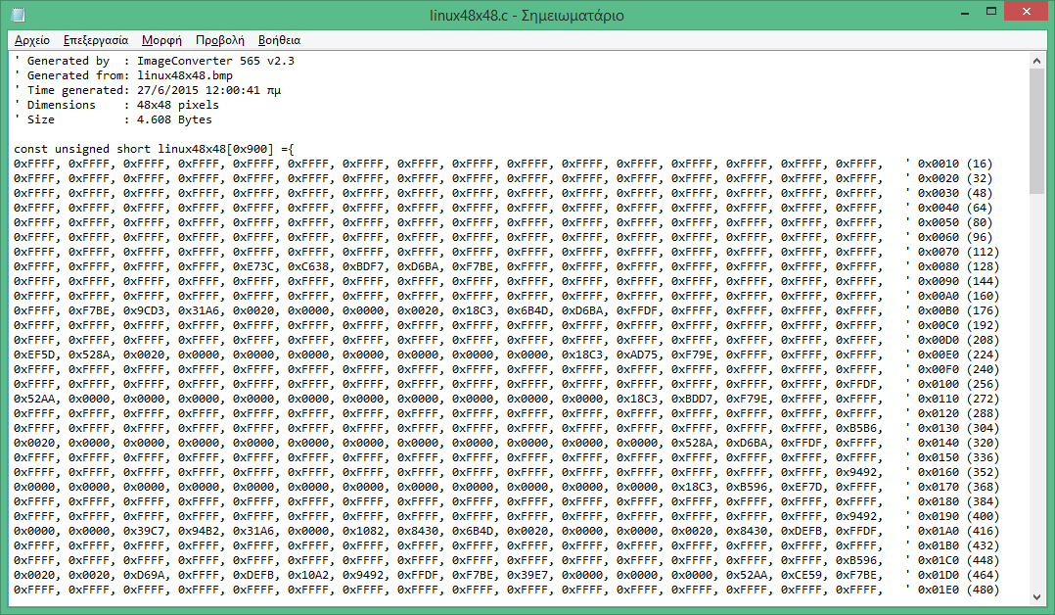

1. Copy all of the data bellow the bracket
2. On SynWrite program create a blank page and name it bmp.h
3. On the top of the page write the command #define Image1 @TableImage1
4. Create the table : Table TableImage1 as Word
5. Make sure your first two entries are the dimentions of your image written in hexadecimal numbers.(In the picture below it is 0x0030 , 0x0030 which is 48x48 in decimal system)

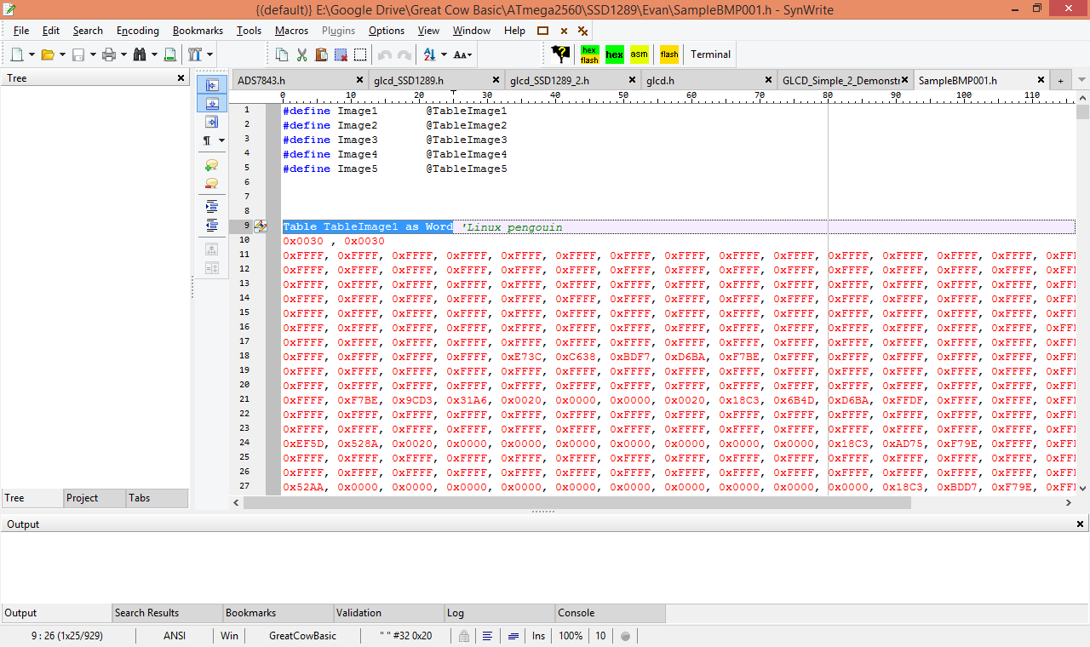

1. Paste the data from the filename.c and close the table
2. Save the file